Robotics Project
Group 1

Keith – Shaun – Robert – Zach

Table of Contents
Project Description 3
Project Plan 4
Gantt Chart 4
Deployment Chart 5
Critical Path Chart 6
Documentation 7
Inventory 7
Program Source 8-9
Programming Notes 9
Design Notes 9
Project Conclusion 10
Outcome 10
Reasons for Success 10
Robotics Project and Logic 10
Glossary 11
Works Cited 12
Reference Materials 12
Resources 12

Project Description
Our project is a Lego Mindstorms® robot whose purpose is to drive around an oval track using the light sensor. The style of our robot is a tread-type robot with two motors. Our robot was built by Zach Shivers, Robert Knebel, Keith Gable, and Shaun Smith, and it completed the large oval track in the ITD Sabre lab in around a minute and 35 seconds.
Lego Mindstorms is a line of Lego sets combining programmable bricks with electric motors, sensors, Lego bricks, and Lego Technic pieces (such as gears, axles, beams, and pneumatic parts) to build robots and other automated or interactive systems (“Lego Mindstorms”).

Project Plan

Gantt Chart
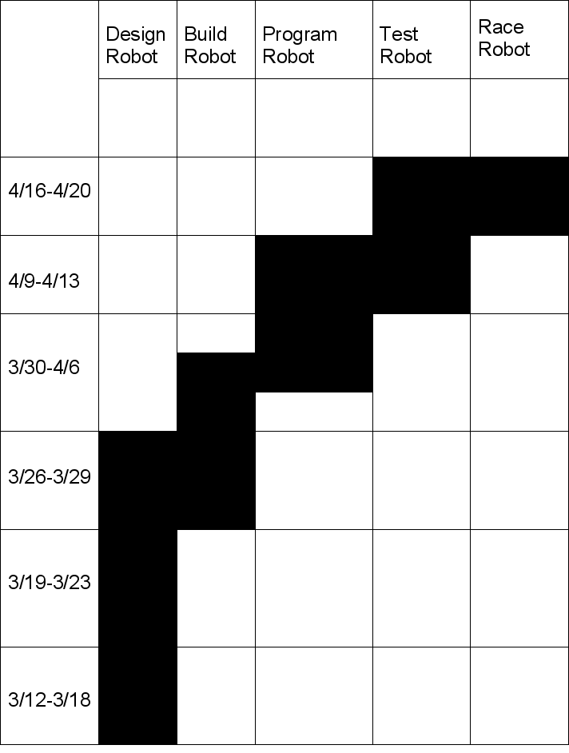

Deployment Chart
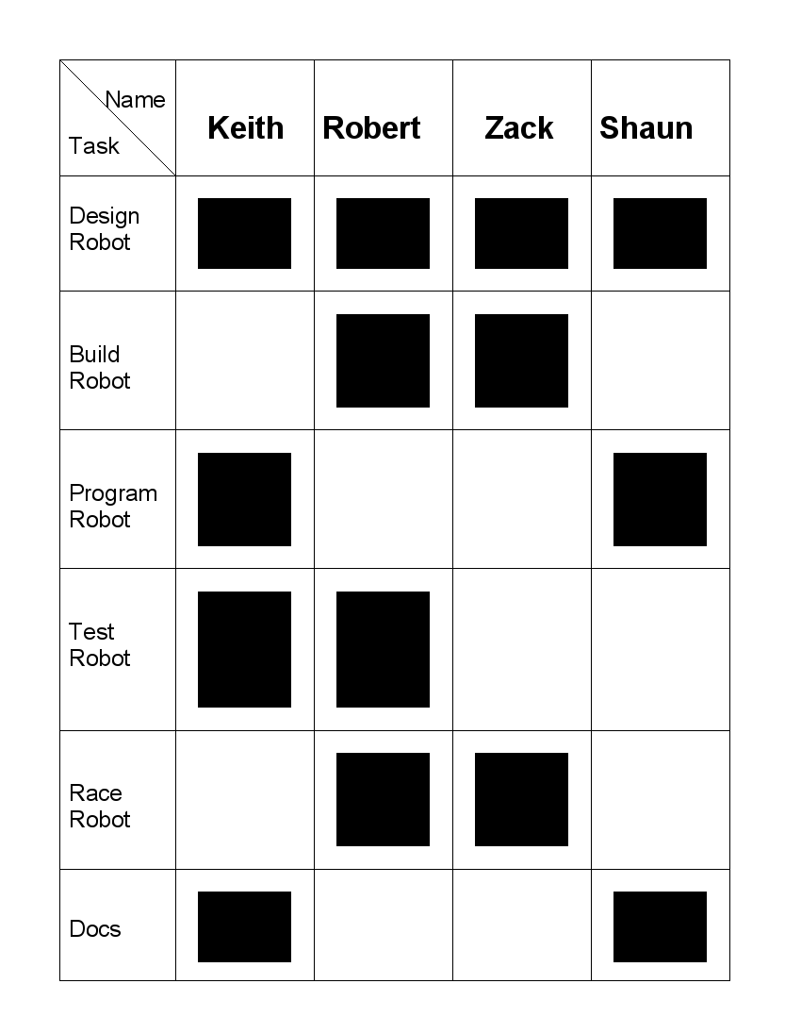

Critical Path Chart
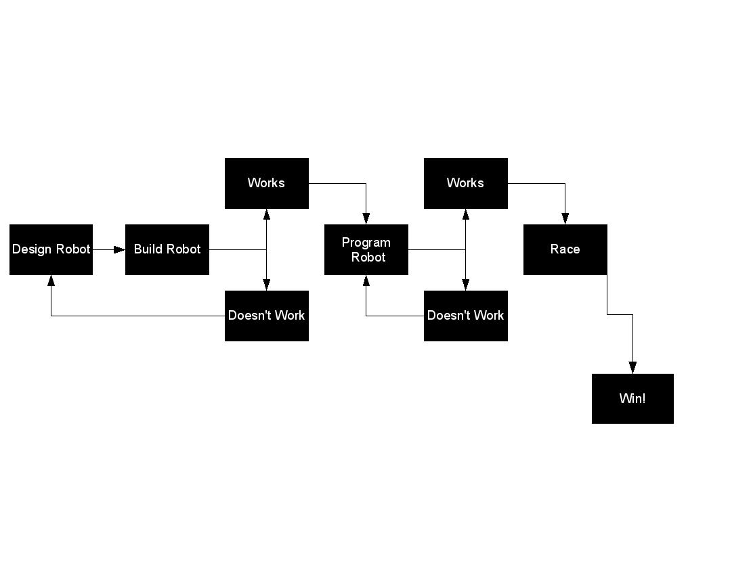

Documentation

Inventory
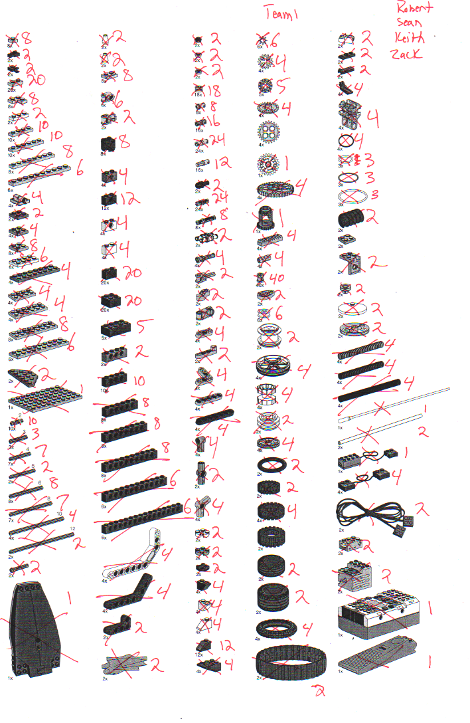

Program Source
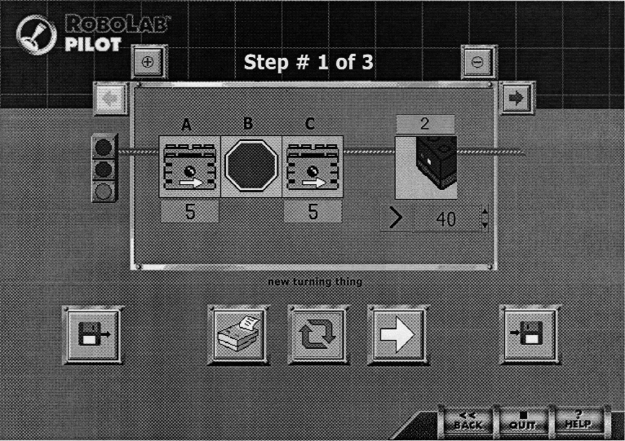
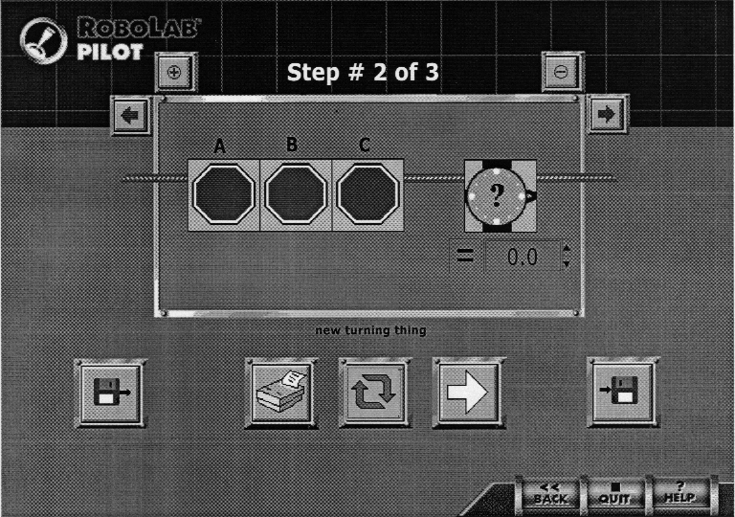

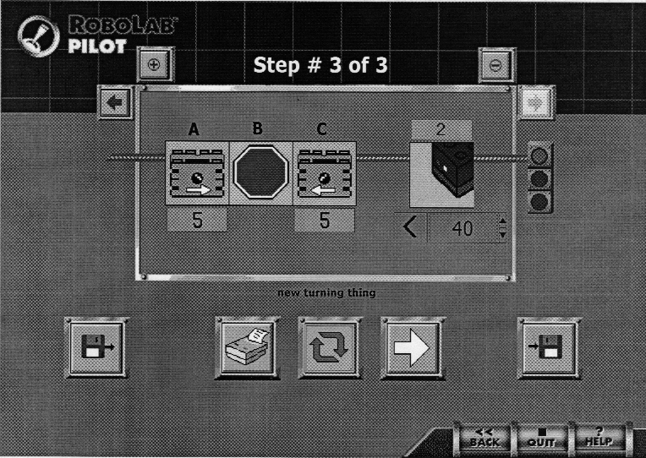

Programming Notes
We attempted to write a program in Robolab Inventor, but the lack of useful help, including the lack of a tutorial on how to set motor speeds during event loops, required us to try other things. We looked around the Internet for an example program that we can build on, and came across TechnologyStudent.com, which has exercises for a similar problem posted, which we followed to create this program. The problem their program solved was going around a circle; we're going around an oval.
Each step can be broken down into simple terms like this:
Step 1: Run motor A and C at full power (5) until light is detected.
Step 2: Stop all motors for 0.0 seconds (Pilot requires you to wait for an event, so a null event is used)
Step 3: Run motor A (the left motor) full speed forward and motor C (the right motor) full speed backwards until dark is detected. The reason we're doing anything with the right motor is because it will turn faster if it doesn't drag the tread.
Repeat until stopped

Design Notes
We followed the directions on how to build the robot out of the robotics book. Once the robot was built, which was not hard to build, we tested the robot to make sure that it ran properly using the built in programs. One problem we encountered is that the gears would slip because of the worm gears Lego had us use. We replaced the worm gears with regular gears and the robot ran well.

Project Conclusion

Outcome
Our robot successfully completed the track in around a minute and 35 seconds, and did so without falling apart or getting off of the track during the middle of the trial. We feel as if our design is the most stable of any other design used during our class's time trials.

Reasons for Success
There are several reasons our project succeeded. The biggest reason is that we replaced the worm gears with standard tooth gears. If we didn't do this, our gears would have slipped out during the time trial, and we would have not completed the track.
Another reason we succeeded is because we researched several possibilities from the beginning, including a drive train, a three wheeler, and using rack and pinion steering. After researching these, we discovered they would not work.

Robotics Project and Logic
The robotics project reinforced several things we learned during class, including problem solving, discovering the real problem, and doing charts. Our program relates to logic because boolean operations are performed, however we did not learn about truth tables or if/then syntax until the robotics project was nearly completed. We had to utilize problem solving skills several times during the course of the project. The first instance was when Robolab refused to work properly on several computers. The second instance was when we needed to actually write the code to solve the problem.

Glossary
LabVIEW – the graphical programming language used by Robolab for programming the RCX
Mindstorms - a line of Lego sets combining programmable bricks with electric motors, sensors, Lego bricks, and Lego Technic pieces (such as gears, axles, beams, and pneumatic parts) to build robots and other automated or interactive systems.
RCX – the microcontroller of the Lego Robotics Invention System (RIS)
RIS – Robotics Invention System
Robolab – the programming software that is part of Lego Dacta that can be used with any RCX brick, powered by the LabVIEW programming language

Works Cited

Reference Materials
"A Design and Technology Site." TechnologyStudent. World Association of Technology Teachers. 19 Apr. 2007 <http://www.technologystudent.com/>.
"LabVIEW." Wikipedia. Wikimedia Foundation. 19 Apr. 2007 <http://en.wikipedia.org/wiki/LabVIEW>.
"Lego Mindstorms." Wikipedia. Wikimedia Foundation. 19 Apr. 2007 <http://en.wikipedia.org/wiki/Lego_Mindstorms>.

Resources
